**VR BASED TELEROBOT**

* **WE ARE VR**

DETAILED REPORT OF THE PROJECT

**Progress Made & Experiment Details:**

We have initially designed the chassis of the robot by referring to a research paper written about the Rocker Bogie Mechanism. Then the UPVC Pipes are used to form the chassis to which vacuum wheels are fitted. These are used inorder to allow the robot to climb effectively over the obstacles by providing sufficient grip. Here we make use of 6 wheels instead of normal rather than 4 wheels.

Then we tried placing the battery on various places of the robot. By considering the shift of the Centre of Mass of the robot during inclination, we finally found the appropriate location to place by experimentation. When it is climbing upwards, the Centre of Mass shifts to the back and in order to bring it back to the centre, to avoid toppling, we placed it in the front side.

We initially used normal (low torque) DC motors to run the robot. But during experimentation we found that it does not provide sufficient torque to climb large obstacles. Hence we replaced it with high torque motors of mentioned specifications which provided enough power to lift its weight even in steep inclinations.

Once the robot is built, then we connect the motors to the motor drivers. These drivers are biased appropriately and the enable signals are obtained from the output of the joystick used by the user. The signal from the joystick is received by arduino 1 and is transmitted by the transmitter 1. The transmitter 2 receives the data and controls the respective motors. Here we use only NRF module for transmission and reception as the range of our prototype is limited.

Now we are trying to use two stepper motors to sweep the camera through X- Axis and Y- Axis. The stepper motors are interconnected to allow the user to have a 180degree view in horizontal direction and 90 degree view in vertical direction, thus providing a First Person View and a sense of reality which is the main motive of our project.

The gyroscope is fitted on top of the VR headset box. As the user moves his/her head, the gyroscope senses it and the readings are sent to the arduino 2 through the Transmitter and Receiver. The values obtained are scaled, processed and given to the stepper motors. By this the user can control the movement of the camera mounted on the robot from his actual position with just the movement of the head.

|  |  |  |  |  |
| --- | --- | --- | --- | --- |
| **COMPONENTS REQUIRED AND ESTIMATED COST** | | | | |
| **Sl No.** | **Components** | **Qty** | **Net Cost** | **Remarks** |
| 1 | Arduino Uno | 2 | 1000 |  |
| 2 | Robot Chassis | 1 | 2000 |  |
| 3 | Robot Wheels | 6 | 400 | Price for both |
| 4 | Camera | 1 |
| 5 | Microphone | 1 |  | Available |
| 6 | Joystick/Smartphone | 1 | 100 |  |
| 7 | Laptop | 1 |  | Available |
| 8 | Gyroscope | 1 | 150 |  |
| 9 | VR Headset | 1 | 1500 |  |
| 10 | Battery | 1 |  | 12V/ 1.2A |
| 11 | Motors | 6 |  | 12V DC Supply/ 500mA/ 8-12 kg/cm2 torque |
| 12 | Motor Drivers | 2 | 1500 | BTS 7960 |
| 13 | Transmitter and Receiver | 2 | 200 | NRF Module |
| 14 | Stepper Motor | 2 | 400 |  |
|  |  |  |  |  |
|  | **Total** |  | **8000** | Inclusive of other unforeseen expenses |
|  |  |  |  |  |

**Schematic Representation:**

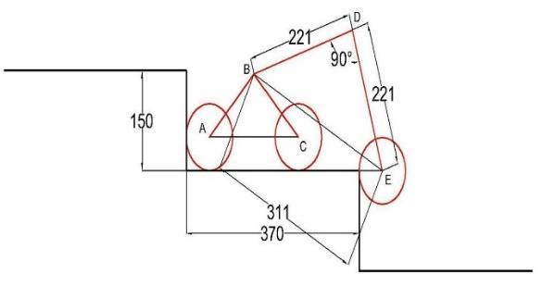

CAD drawing of both triangles

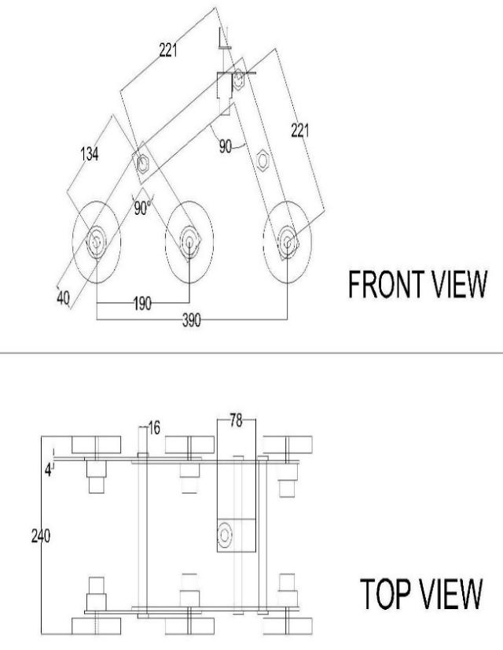2D Drawing of Rocker Bogie Mechanism